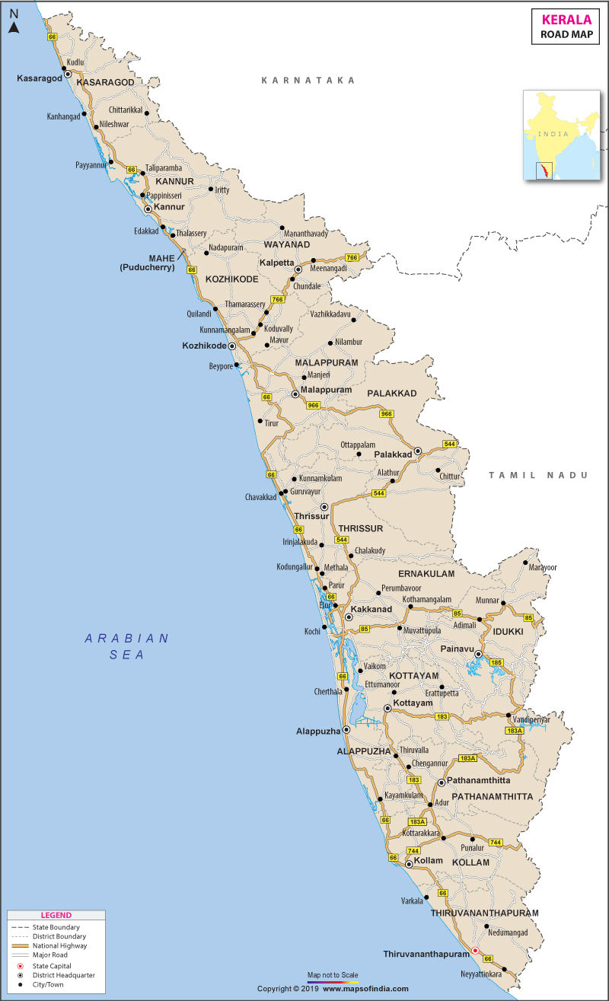
MUNNAR TOUR
ITINERARY PUBLISHED:
15 OCT’26 | DAY 01 | ARRIVE COCHIN – MUNNAR (126Kms, 03Hrs drive)
Meeting and assistance upon arrival at Cochin airport and drive to hotel. Upon arrival check in at hotel.

Overnight stay in Munnar

16 OCT’26 | DAY 02: | MUNNAR
Morning after breakfast proceed for sightseeing tour of Munnar visiting Mattupetty Dam & Lake – A Picturesque Haven in the Hills : Set amidst the verdant hills of Munnar and close to the majestic Anamudi Peak, Mattupetty is a beautiful mountain retreat situated at an elevation of approximately 1,700 metres above sea level and around 13 kilometres from Munnar. Blessed with rolling green valleys, refreshing mountain air, and a wonderfully tranquil atmosphere, Mattupetty offers a delightful escape into the natural beauty of Kerala’s highlands. The principal attractions here are the Mattupetty Dam and Lake, which together create one of the region’s most scenic landscapes. The dam is a concrete gravity structure constructed in the late 1940s as part of the Pallivasal Hydro-electric Project, primarily for water conservation and power generation. Over the years, the reservoir has become much more than an important source of water and hydroelectric power. Its constant supply of water has also created a favourable environment for birds and wildlife, adding another dimension to the natural appeal of the area. The tranquil lake, embraced by forested slopes and lush green hills, provides a stunning setting for visitors to pause and appreciate the surrounding scenery. A visit to Mattupetty is an opportunity to experience the quieter side of Munnar—where crystal-clear waters, emerald hills, cool mountain breezes, and abundant natural beauty come together in perfect harmony. Whether enjoyed as a leisurely stop during a sightseeing excursion or as a moment to simply soak in the magnificent surroundings, Mattupetty remains one of the most charming landscapes in the Munnar region.

Munnar Rose Garden – A Floral Haven Amidst the Hills : Perched at an elevation of around 3,500 feet above sea level, the Munnar Rose Garden is a charming two-acre retreat located just a short distance from the town centre. Set against the lush backdrop of Munnar’s rolling hills, the garden offers visitors a delightful opportunity to step into a world of vibrant colours, enchanting fragrances, and abundant greenery.While roses are undoubtedly the garden’s highlight, the attraction extends far beyond its beautiful blooms. Well-maintained pathways meander through a diverse collection of flowers, aromatic spices, exotic plants, and fruit-bearing trees, creating a wonderfully varied botanical experience. Among the greenery, visitors can discover fragrant cardamom and vanilla, alongside fruit plants such as litchi, strawberry, and rambutan. The garden’s colourful floral displays and peaceful surroundings make it an inviting place to stroll at a leisurely pace, enjoy the fresh mountain air, and capture beautiful photographs. The combination of blooming flowers, verdant hills, and the gentle fragrance of spices creates a refreshing sensory experience that reflects the natural richness of Munnar.

Attukad Waterfalls – A Cascading Jewel of Munnar: Tucked away between Munnar and Pallivasal, Attukad Waterfalls is a captivating natural retreat where cascading waters, forested slopes, and rugged mountain landscapes come together in remarkable harmony. Surrounded by undulating terrain and dense greenery, the waterfall offers a refreshing escape into the quieter side of Munnar and is a favourite among both visitors and locals. The journey to Attukad is part of the experience, with the route leading through scenic landscapes and across a charming narrow bridge. From a distance, the waterfall appears like a delicate silver ribbon descending through the emerald hills; as you approach, its true grandeur unfolds as the waters tumble dramatically down the rocky slopes. The waterfall is particularly spectacular during the monsoon season, when the surrounding landscape turns lush and vibrant and the cascading waters gather greater strength. The area also offers opportunities for nature walks, trekking, and hiking, allowing outdoor enthusiasts to appreciate the surrounding wilderness at a leisurely pace.

Overnight stay in Munnar

17 OCT’26 | DAY 03: | MUNNAR – PERIYAR (96Kms, 03Hrs drive)
Morning after breakfast drive to Periyar. Upon arrival check in at hotel in Periyar.

Rest of the day free for relaxation / explore surrounding.

Overnight stay at Periyar

18 OCT’26 | DAY 04: | PERIYAR
Morning after breakfast proceed for boat ride on the tranquil waters of Periyar Lake offers one of the most rewarding ways to experience the wilderness of Thekkady. Cruising gently along the lake and its forest-fringed banks, visitors have the opportunity to observe wildlife emerging from the dense greenery, often creating unforgettable moments in the heart of nature. The surrounding forests are home to a remarkable variety of wildlife. Elephants, gaur (Indian bison), sambar deer, wild boar, Nilgiri langurs, otters, and flying squirrels are among the species that may be encountered during the cruise. The sight of elephants gathering along the water’s edge or wild animals moving quietly through the forest makes the experience particularly captivating.

Afternoon enjoy the spice plantation tour in Periyar.

Overnight stay at Periyar

19 OCT’26 | DAY 05: | PERIYAR – ALLEPPEY (129Kms, 03Hrs drive)
Morning after breakfast drive to Periyar. Upon arrival check in at hotel in Alleppey

Rest of the day free for independent activity / explore surrounding

Overnight stay in Alleppey

20 OCT’26 | DAY 06: | ALLEPPEY – COCHIN (53Kms, 01Hrs drive) – DEPART COCHIN
Morning after breakfast drive to Cochin airport to board flight for onward destination

TOUR COST:
UNIT | PER PERSON COST
Cost for 05 nights, 06days Kerela | INR 24,353 per person

CITY | HOTEL | NIGHTS
Munnar | Eastend or similar | 02 Night
Periyar | Abad Green Forest or similar | 02 Night
Alleppey | Haveli Backwater or similar | 01 Night
Total number of nights |  | 05 Night

Our prices include:

Accomodation in a Double room.

Bed and breakfast basis as per program

All arrival/departure transfer, sightseeing tour excursions by Air-conditioned vehicle.

Boat ride at Lake Periyar

Spice plantation tour

02 night in Munnar with bed and breakfast.

02 nights in Periyar with bed and breakfast

01 night in Alleppey with bed and breakfast

Government tax.

Our prices do not include:

Air fare

Service of English speaking guide

Entrance fees to monuments

Tips for guides (at the client's discretion).

Travel and cancellation insurance (optional).

Beverages.

Any services not mentioned as included, including personal extras such as telephone calls, laundry

service, etc.

